**SEERAT-UN-NABI (S.A.W)**

**PART-I**

* Birth & Early Life.
* Death of Mother and Grand Father.
* Journey To Syria (SHAM).
* The Battle Of Fajjar.
* Youth.
* Marriage With Hazrat Khadija (R.A).
* Hilful Fadul.
* Arbiteration.
* Declaration of Prophethood(S.A.W).
* The Call.
* The Early Converts.
* Call At Safa.
* Opposition And Persecution.

**CAUSES OF OPPOSITION**

* Migration To Abysinnia First Group( ).
* Migration To Abysinnia Second Group( ).
* Hazrat Umer Farooque (R.A) accepted Islam.
* Boycott Of Banu Hashim And Shaab Abu Talib.
* The Year Of Sorrow.
* Isra And Miraj.
* Journey To Taif.
* The First Pledge Of Al-Aqabah.
* The Second Pledge Of Al-Aqabah.
* Migration To Madinah.
* Importance Of Hijrah.
* Mosque of Quba.

**FIRST YEAR OF HIJRA.**

* Mosque Of The Prophet(S.A.W).
* Ashab-e-Suffa.
* The Brotherhood.
* Charter Of Madinah.

Change of Qabila.

***Serat Life of the Holy Prophet:***

*Birth and (P.B.U.H) life of Makkah:*

Hazrat Muhammad (S.A.W) was born in Makkah Mukarramah his father was Hazrat Abdullah, The son of Abdul muttalib. Hazrat Aminah was his mother. Hazrat Abdullah passed away born. Hazrat Halima sadia (R.A) took our Nabi (S.A.W) to the country side ( and cared for him there for hears the mother of Nabi (S.A.W) passed away when he was six years old after mother passed away his grandfather Abdul muttalib took care of him. He lost his affectionate ( ) grandfather too then at the age of eight he was at last taken to the care of his uncle Abu talib. (Rasoolullah (S.A.W) was obedient as a child. He always spoke the truth and showed good manners from a very young age hazrat Muhammad S.A.W was kind helpful and honest to all people left their goods with hi for safekeeping ( ). He was called “AS SADIQ “(The truth full) and “AL AMEEN” (The trustworthy). Hazrat Muhammad (P.B.U.H) was totally different from the people among whom he was born and he passed his youth ( ). He never told a lie even his worst enemies never accused ( ) him of telling a lie on why occasion during his entire life he talked politely. Which he captivated ( ) the hearth of those who came in contact with him in his dealings with the people he always followed the principles ( of justice ( ) and fair play Hazrat Muhammad born among a people who regarded drinking and gambling ( ) as virtues ( ) he never touched a alcohol and never indulged ( ) in gambling. His people were uncouth ( ) uncultured ( ) and unclean but he personified ( ) in himself the highest standard of culture. He was such a lover of peace that his heart melted ( ) for them when they took up arms ( ) and cut each other’s throat ( ). Hazrat Muhammad is a shepherd ( ) of humanity always thinking about their welfare and trying to lead them along the straight path to their well being. He regarded nothing in the heavens ( ) and the earth worth worship except the one true Allah he did not bow ( ) before any created thing and did not partake ( ) of the offerings made to idols ( ). By the time he ways twenty five had become well known in the city for the integrity ( ) of his character and his honesty in his dealings a rich widow khadijah entrusted ( ) to him management of her commercial affairs and he took her goods for sale Hazrat Muhammad (P.B.U.H) Performed his duty with honesty and returned with huge profits she was impressed by Muhammad honesty and nobility and offered him marriage at that time she was forty and Hazrat Muhammad (P.B.U.H) was only twenty five. The union ( ) proved most successful ( ). His marriage hazrat Muhammad (P.B.U.H) become more and more absorbed ( ) in spiritual meditation ( ). He used to retire ( ) during the whole month of ramzan to Ghari-i-Hira. When one night towards the end of the month of ramzan an angel came to visit him and announced that almighty.

**Hilf al-Fudul**

This event took place in the earlier days of youth of Muhammad (s.a.w.s.). This nobly active youth gathered the youths of the tribes like Bani Hashim, Bani Asad, Bani Zuhra, Bani Qaiyim in the house of an old gentleman named Abdullah ibn Jazan and formed an organization in which oath was taken from every youth that he would help every oppressed person in Mecca or who came to Mecca from another place and met with problems; that if someone oppresses others he will be made to give what was due to the oppressed justly. This pact was called Hilful Fuzul.

It is all the more worthwhile to hear the truth from others. Just see what an expert western historian has written:

The Hilful Fuzul organization was like an army formed by a group of brave and courageous justice-loving youths. It was constituted to ensure that each and every oppressed person gets justice and his or her dues. These soldiers were not taking any remuneration from anyone but were serving the society voluntarily. In those days the Arab Bedouins acted freely in whatever way they liked. There was none to check their behavior. If anyone from a tribe killed a member of another Arab tribe the whole tribe of the killed one would wage an all out war against the whole tribe of the killer. There were no norms for warfare.

There was neither police in Mecca nor any court. Every tribe formed their own rules. If anyone arrived in Mecca from another area and fell a victim of oppression there, he had no one to help. He would have to bear the injustice or return from Mecca , complain to his tribe who may come and fight with the Meccans in revenge. But if any tribe from outside arrived to fight with any Meccan tribe, it was being regarded as an insult to the tribe of Quraish and all the Meccan tribes would jointly fight with the outsiders. Therefore, hardly any tribe from out of Mecca ever dared to wage a war with Meccans.

In such circumstances the above-mentioned youths of Hilful Fuzul used to help every oppressed person. They gathered around the Holy Ka’ba and swore that they would never forget their responsibility of assisting every oppressed person and would assure that the oppressed one got his rightful dues, even if the oppressor was the richest or the most influential person. That is why these volunteers used to rush to help even if the oppressed one did not belong to Mecca , even if he came from another part of the country.

The Holy Prophet (s.a.w.s.) himself once said: The best part of my past life was spent in the activities of Hilful Fuzul. That service has given me much honor and respect. I would not have stepped out of that agreement even if I were to be offered one hundred red camels.

The same western author writes further: This noble formation of Hilful Fuzul was the main achievement of the youthful days of Muhammad (s.a.w.s.), which took place before he was made the messenger of God. It is noteworthy that the idea of providing justice to everyone came to Muhammad (s.a.w.s.) at a time when nobody there even thought of any kind of human rights. Thus it was a very big revolution in social life. His activities weakened all oppressors and when the Holy Quran spread its light every sort of ignorance and darkness was removed from the land. Before that no one ever dared to question an oppressor.

In addition to the aforesaid moral virtues Muhammad (s.a.w.s.) was full of God-given intelligence and wisdom. Otherwise how could he be a prophet? His power of making the most appropriate decisions in every social, personal or political problem was extremely wonderful.

**THE FUJJAR (UNJUST) BATTLES**

**Introduction:**

Detailed account of such matters is beyond the scope of our book. However, we give below in brief the causes and the events of these battles, in one of which the Holy Prophet (S.A.W) also participated, so that the esteemed readers may not remain totally uninformed about them.

The Arabs of the Age of Ignorance spent the whole year in fighting and plundering. However, the continuance of this state of affairs deranged their lives. For this reason they did not fight during four months in a year (viz. Rajab, Zi Qa'd, Zil Hajj and Muharram) so that their might open their trade markets during these four months and engage themselves in work and earning of livelihood. [01]

In view of this resolution the bazaars of 'Ukaz, Mujannah and Zil Majaz witnessed wonderful gatherings during these four months and friends as well as foes engaged themselves, side by side with one another, in buying and selling as well as in self glorification. The great singers of Arabia sang their compositions in these assemblies. The well-known orators delivered speeches. The Jews, the Christians and the idolaters presented their religious beliefs before the Arab world without any fear of harm from their opponents.

During the course of Arabian history, however, this covenant was broken four times, when some Arab tribes engaged in war-fare with one another. And as these battles were fought in the months in which fighting is prohibited they are called Fujjar Battles. Now we give below a very brief account of these battles

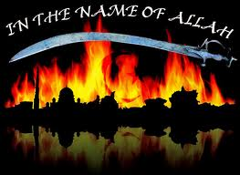

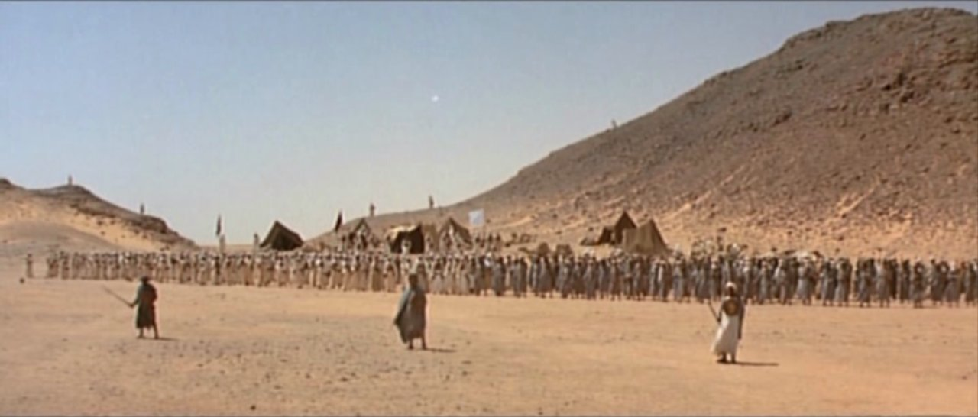

**The First Fujjar:**

The two warring parties were the tribes ot 'Kananah' and 'Hawazan' and the cause of the battle has been mentioned to be this: A person named Badr bin Ma'shar selected a place for himself in the bazaar of 'Ukaz and read out self-glorifying verses every day before the people. One day he stood up, with sword in hand, and said 'O people' I am the most honorable person and if anyone repudiates this claim of mine he shall be put to sword'. In the meantime a man rose up, struck a sword on Badr's foot and severed it. For this reason the two parties grappled with each other but stopped fighting before anyone was killed.

**The Second Fujjar:**

The reason for this battle was that a beautiful woman of the tribe of Bani 'Amir attracted the eyes of a young man who requested her to show him her face. The woman declined to do so. The lustful young man sat behind her and sewed together her long laps with thorns so that when she got up her face became visible. At that moment both of them called their tribes. The two tribes stopped fighting only after some persons had been killed.

**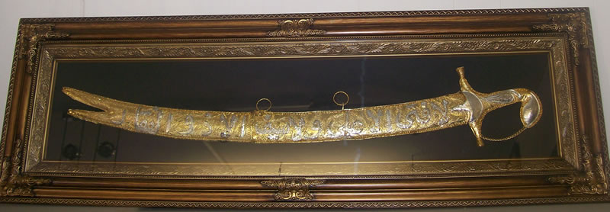**

**The Third Fujjar:**

A man belonging to the tribe of Kananah was indebted to another who belonged to the tribe of Bani Amir. The debtor was dilly-dallying. The two persons began to quarrel on this account. A bloody fight was doing to start between the two tribes, but, before the situation worsened, the matter was settled peacefully.

**The Fourth Fujjar:**

It is the very battle in which the Prophet (S.A.W) participated personally. There is a difference of opinion about his age at that time. Some say that he was fourteen or fifteen years of age whereas others have written that he was then twenty years old. However, as this war continued for four years, it is possible that all these versions mall be correct. [02]

The root cause of this dispute has been stated to be this. No'man bin Manzar used to arrange a caravan every year and sent merchandise to 'Ukaz, so that, hides, ropes and brocade might be bartered from there. A man named 'Urwatur Rijal, who belonged to the tribe of Hawazan, took responsibility to safeguard and protect the caravan. However, Baraz bin Qays, a member of Kananah tribe, became very sentimental about a man of Hawazan tribe having surpassed him. He went to No'man bin Manzar and complained about the arrangement but met with no success. He became annoyed and jealous and was constantly waiting for an opportunity to deal with 'Urwarur Rijal on the way. Eventually he killed him in the territory of Bani Marrah and thus besmeared his hands with the blood of a member of Hawazan tribe. In those days the tribes of Quraysh and Kananah were allies and this development took place when the Arabs were busy in trade in the market-place of 'Ukaz. A man informed Quraysh about what had come to pass. Hence, the tribes of Quraysh and Kananah collected their belongings and hurried towards the Harem (a distance of four leagues around Makah is called the Harem and fighting in this area was unlawful amongst the Arabs) before Hawazan tribe should become aware of the happening. However, members of Hawazan tribe pursued them and, before they could reach within the limits of the Harem, fighting commenced between the two parties. At last they had to stop fighting on account of night fall. Quraysh and Kananah tribes availed of this opportunity to escape to the Harem in darkness and thus became safe from the enemy's attack. After that day Quraysh and their allies came out of Harem sometime or the other and fought with the enemies. On some days the Prophet (S.A.W) also participated in the battles along with his uncles, as mentioned above. This state of affairs continued for four years. At last the war came to an end by paying of the blood money to Hawazan tribe, who had lost more lives as compared with Quraysh. [03]

References:

**1)** It may be gathered front verse 36 of Surah al-Tawbah that prohibition of war-fare during these four months had a religious origin and the Arabs did not repudiate this prohibition.

**2)** Tarikh-i Kamil, vol. I, 358 - 359 and Seerah-i Ibn Hisham, vol. I, page 184.

**3)** Seerah-i Ibn Hisham, vol. I, pp. 134 - 187.

*Declaration of prophet hood:*

Allah had chosen him as his messenger to all mankind .The angle taught him the mode of ablution ( ) and the way of worshipping allah he communicated to him the divine ( ) message.

96_1.png

Recite in the name of your Lord who created

96_2.png

Created man from a clinging substance.

96_3.png

Recite, and your Lord is the most Generous –

96_4.png

Who taught by the pen –

96_5.png

Taught man that which he knew not

“Read: In the name of your Allah who created man from a clot”.

“Read: And your Allah is the most bounteous who thought by the pen. Taught man what he know not”

He was forty years old when this happened.

*Preaching and its difficulties:*

The holy prophet (P.B.U.H) began by preaching secretly. Three years after proclamation Allah ordered his Nabi to preach the message of Islam openly. First among his friends then among the member of his own tribe. Most of the people of makkah refusing to accept Islam they thought that the worship of idols was right they laughed at the teaching of hazrat Muhammad (P.B.U.H) and called him with bad names the quraish did not like to hear about one Allah they began to hate ( ) Hazrat Muhammad (P.B.U.H) and his teaching . When the Quraish saw that the Muslims refused to change their religion they began harming ( ) the Muslims hazrat bilal (R.A)a slave ( ) was made to lie ( ) on the hot desert sand ( ) and whipped ( ) by his master ( ) hazrat sumayyah (R.A) was martyred ( ) with an spear ( ) other muslims were beaten to force them to leave Islam but they did not leave even hazrat Muhammad (S.A.W) in peace while he was performing salah they threw dirt on him abu lahab was the uncle and neighbor for hazrat Muhammad (P.B.U.H) he threw filth ( ) at doorstep of hazrat Muhammad (P.B.U.H) his wife spread ( ) thorns ( ) in the path of hazrat Muhammad (P.B.U.H) . Hazrat Muhammad (P.B.U.H)never took revenge ( ) kuffar offered ( ) him money beautiful woman to make him their king hazrat Muhammad (P.B.U.H) did not accept their offer because he was ordered by allah to spread islam as the Muslims suffered ( ) a great death at the hands of the cruel ( ) kuffar hazrat Muhammad (P.B.U.H) gave them permission to leave makkah Migration (Hijrat).

83 men and 18 women to Abyssinia this was the first hijrat in Islam the quraish sent a group of people to bring to Muslims back. The king najashi turned down the request of the quraish and allowed the Muslims to stay.

*Boycott of banu hashim:*

The kuffar became more angry they decided to harass ( ) the family of hazrat Muhammad (P.B.U.H) the kuffar exiled ( ) them to a small section of makkah the Muslims remained in this place for three years nobody was allowed to sell ( ) them food or help them in any way

*Year of Sorrow ( ):*

After three years of hard ship this cruet boycott ( ) had a bad effect on the health of hazrat khadijah (R.A) and Abu talib shortly after the boycott both passed away one after the other hazrat Muhammad (P.B.U.H) very sad . He lost two of his best supporters ( ). This year is called aam-u-huzan

*Journey to Taif:*

When Hazrat Muhammad (P.B.U.H) saw that the people of makkah were not accepting Islam he decided to go to taif. The people of taif refused to accept his message. Stone were thrown at him and he was chased ( ) out of the town bleeding and tired hazrat Muhammad (P.B.U.H) took shelter in the garden of utbah bin rabee. The annual pilgrimages ( ) of Kaaba brought to makkah-au-mukarmah people from all parts of Arabia. Hazrat Muhammad (P.B.U.H) tried to convey the message of Allah. There he met some inhabitants ( ) of yashrib, who had some notion of prophets and divine ( ) messages ( ) so they decided not to lose time and forth with embraced ( ) Islam.

*Miraj: ( 11th years after the proclamation of prophet hood)*

Miraj means the journey of hazrat Muhammad (S.A.W) to seven heavens Rasulullah (S.A.W) was taken from makkah to masjid-ul-Aqsa in Jerusalem on burq from Jerusalem, he went to the seven heavens. He met all the ambiya (A.S) and at last he met with allah ta’ala too . It was during the miraj that allah Ta’ala gave hazrat Muhammad (S.A.W) the five daily salah as a gift for the muslims, making it faraz (Obligatory) on all the muslims. This journey of miraj took place very quickly during the night.

*Migration to madina:*

Before the coming of islam, madinah was called “yasrib”. The people living there were “Mushrikeen” Who worshipped idols. There were two tribes living there “AWS” and “KHAZRAJ”. There were also Jewish tribes living in around madinah. These tribes were the “Banu Quraizah “, “Banu Nuzeer” and “Banu Qaynuqa” 72 people came to makkah for hajj accepted Islam at the hands of Nabi (S.A.W) during the hajj period. This group requested Nabi(S.A.W) to live in madinah. After most of the sahabah (R.A) had already left, it was time for nabi (S.A.W) to leave. The kuffar worried . The leaders of kuffar help meeting to decide to cut the root of islam, I.e martyr nabi (S.A.W) according to their plan the kuffar surrounded the house of nabi (S.A.W) nabi left the house in the shade ( ) of allah’s protection ( ) he reached surah yaseen. He stepped out righting front of the kuffar and blew dust in their eyes. Allah made it such that they were all blinded as Nabi (S.A.W) was leaving makkah The night was already ending when nabi left makkah and they reached a mountain soor Nabi and hazrat abu Bakar (R.A) stayed over in a cave. When the kuffar saw that nabi (S.A.W) was not coming out of the house the next morning they became worried. They also made an announcement that the person who captures ( ) nabi (S.A.W) will receive a reward of hundred camels a person by the name of suraqa was greedy ( ) for the reward. When he got very close to them he horse sank ( ) in ground now suraqa lost all hope of the reward as they proceeded ( ) for madinah on the road to madinah is a place called Quba where nabi (S.A.W) build a masjid this was the first masjid . Sas full if joy he stayed at the house of abu Ayoub Ansari . After nabi (S.A.W) and his companion ( ) settled in madinah they decided to build a masjid there nabi (S.A.W) and his companions workman in the building of the masjid. A platform was raised in the corner of the courtyard ( ) of masjid-e-nabawi (S.A.W) for the residence of such followers who had no home or family and they were known as ashab-e-suff ( ). It was the traning center for Islamic education and also a shelter for poor muslims.

*Brother Hood: (Maeakhat)*

After hijrat the prophet (S.A.W) established the relationship of brotherhood between the muhajareen and the ansar as well as between aus and khazzraj. Muhajareen were the quraish. Who had migrated from makkah to madina the ansar who had accepted islam the muhajareen were in a dire ( ) condition as they had abandoned ( ) their property. Riches and houses for the sake ( ) of their faith the ties ( ) between both the groups were cemented ( ) by brotherhood. Every ansar had to share his wealth ( ) and property ( ) with his muhajar brother.

And remember! allah’s favor unto you: how you were enemies and he mad friendship between your hearts so that you became as brothers by his grace.

Allah Muslims are brother

**[Treaty Messaq-i-Madina]:**

Muslims, after their hijrat faced internal and external dangers in madina. The external danger was the attack by the quraish of makkah. The internal danger was the conspiracies of the Jews against the Muslims. This had been instrumental ( ) in creation rift ( ) between the two tribes of madina Aus and khazrij. Now they tried to create conflict between. Ansar and muhajreen. The holy prophet (P.B.U.H) in order to save the Muslims from the conspiracies ( )of the jews, executed ( ) an agreement ( ) with them which is known in the history as messq-i-madina or charter of madina.

The following were the main points of this charter.

1. **The Muslims and the Jews will become friends of each other.**
2. **The Muslims and the Jews in case of war will help each other.**
3. **Nobody will give protection to the quraish of makkah.**
4. **The Muslims Jews and all other minorities ( ) will have complete religions freedom.**
5. **The old customs ( ) of ransom ( ) and blood money for killing will remain intact ( ).**
6. **If any enemy attacked madina, both the Muslims and the Jews will defend it.**
7. **Shedding ( ) of blood in madina will be unlawful ( ).**
8. **Helping the oppressed ( ) will be the responsibilities of both the Muslims and he Jews.**
9. **The prophet will decide all the diputers and his decision would be final.**